MySQL ON DELETE CASCADE example
Let’s take a look at an example of using MySQL ON DELETE CASCADE .
Suppose we have two tables:buildings and rooms .In this database model, each building has one or more rooms. However, each room belongs to one only one building. A room would not exist without a building.
The relationship between the buildings and rooms tables is one-to-many (1:N) as illustrated in the following database diagram:
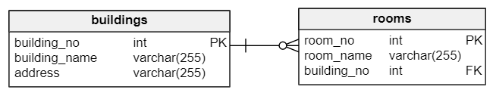
When we delete a row from the buildings table, we also want to delete the rows in the rooms table that references to the rows in the buildings table. For example, when we delete a row with building no. 2 in the buildings table as the following query:
DELETE FROM buildings
WHERE
building_no = 2;

We want the rows in the rooms table that refers to building number 2 will be also removed.
The following are steps that demonstrate how MySQL ON DELETE CASCADE referential action works.
Step 1. Create the buildings table:

CREATE TABLE buildings (
building_no INT PRIMARY KEY AUTO_INCREMENT,
building_name VARCHAR(255) NOT NULL,
address VARCHAR(255) NOT NULL
);

Step 2. Create the rooms table:

CREATE TABLE rooms (
room_no INT PRIMARY KEY AUTO_INCREMENT,
room_name VARCHAR(255) NOT NULL,
building_no INT NOT NULL,
FOREIGN KEY (building_no)
REFERENCES buildings (building_no)
ON DELETE CASCADE
);

Notice that we add the ON DELETE CASCADE clause at the end of the foreign key constraint definition.
Step 3. Insert data into the buildings table:
INSERT INTO buildings(building_name,address)
VALUES('ACME Headquaters','3950 North 1st Street CA 95134'),
('ACME Sales','5000 North 1st Street CA 95134');

Step 4. Query data from the buildings table:
SELECT * FROM buildings;
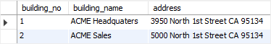
We have two rows in the buildings table.
Step 5. Insert data into the rooms table:
INSERT INTO rooms(room_name,building_no)
VALUES('Amazon',1),
('War Room',1),
('Office of CEO',1),
('Marketing',2),
('Showroom',2);

Step 6. Query data from the rooms table:
SELECT * FROM rooms;
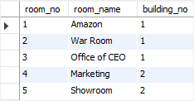
We have 3 rooms that belong to building 1 and 2 rooms that belong to the building 2.
Step 7. Delete the building with building no. 2:

DELETE FROM buildings
WHERE
building_no = 2;

Step 8. Query data from rooms table:
SELECT * FROM rooms;

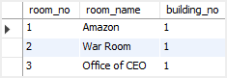
As you can see, all the rows that reference tobuilding_no 2 were deleted.

